2. SIMPSON’S 3/8 RULE
AIM: TO WRITE A PROGRAM IN PYTHON TO DEMONSTRATE SIMPSON’S 3/8 RULE.
PROGRAM:
# Simpson's 3/8 Rule for I = ∫(0 to 1) e^(-x^2) dx with n = 3
import math

# Define the function
def f(x):
return math.exp(-x**2)

# Given values
a = 0 # lower limit
b = 1 # upper limit
n = 3 # must be a multiple of 3 for Simpson's 3/8 rule

# Step size
h = (b - a) / n

# Generate x and f(x)
x = [a + i * h for i in range(n + 1)]
f_values = [f(xi) for xi in x]

# Display table
print("--------------------------------------------------")
print(" i | x(i) | f(x(i)) = e^(-x^2)")
print("--------------------------------------------------")

for i in range(n + 1):
print(f"{i:<3} | {x[i]:<8.6f} | {f_values[i]:<10.6f}")
print("--------------------------------------------------")

# Apply Simpson's 3/8 rule formula (for n=3)
I = (3 * h / 8) * (f_values[0] + 3*f_values[1] + 3*f_values[2] + f_values[3])

# Step-by-step output
print(f"\nh = (b - a) / n = ({b}) / ({n}) = {h:.6f}")
print("\nUsing Simpson's 3/8 Rule:")
print(f"I = (3h/8) * [f(x0) + 3f(x1) + 3f(x2) + f(x3)]")
print(f"I = (3*{h:.6f}/8) * [{f_values[0]:.6f} + 3*{f_values[1]:.6f} + 3*{f_values[2]:.6f} + {f_values[3]:.6f}]")

# Final result
print("\n--------------------------------------------------")
print(f"Approximate value of the integral I = {I:.6f}")
print("--------------------------------------------------")

OUTPUT:
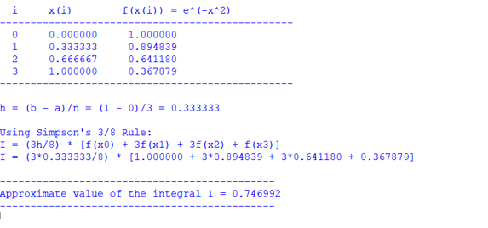
CONCLUSION: THE ABOVE PROGRAM HAS BEEN EXECUTED SUCCESSFULLY.

